Lecture 4
CHEMISTRY OF BIOMOLECULES
Biochemistry is concerned with the chemical components of the human body- their properties, functions, synthesis, transport and degradation. These are called biomolecules. Major classes of these molecules include carbohydrates, lipids, proteins and Nucleic acids. The building blocks of these compounds are the simple sugars, fatty acids, amino acids and mononucleotides. Carbohydrates (CHOs) are compounds containing C, H and O and having the general formula C_{n}H_{2n}O_{n}. Carbohydrates are widely distributed in plants and animals where they play important structural and metabolic roles. Glucose is the most important carbohydrate.
Most dietary CHO is absorbed into the bloodstream as glucose formed by the hydrolysis (breakdown) of dietary starch and disaccharides. Other sugars are also converted to glucose in the liver. Glucose is the major metabolic fuel of mammals and a universal fuel of fetus. It is the precursor for the synthesis of all other CHOs in the body, including glycogen for storage, ribose and deoxyribose in nucleic acids, galactose for synthesis of lactose in milk, in glycolipids and in combination with proteins in glycoproteins and proteoglycans. Diseases associated with CHO metabolism include Diabetes Mellitus, Galactosemia, Glycogen storage diseases and Lactose intolerance.

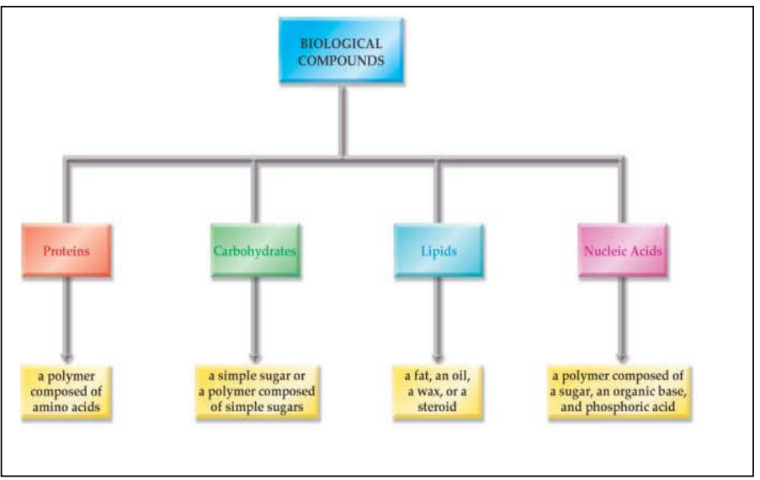
Fig. 9: Biomolecules.

CHEMISTRY OF CARBOHYDRATES I
Definition and Classification of Carbohydrates
Carbohydrates can be defined as optically active polyhydroxyaldehydes or polyhydroxyketones or substances that yield one of these compounds upon hydrolysis.

Functions of carbohydrates:
- Structural component of cells
- Major source of energy
- Storage substances of potential energy
- Regulation of fat metabolism
- Protein sparing function
- Role in gastrointestinal function
- Cell recognition
- Supportive function
- Anticoagulants

Carbohydrates are classified according to the number of sugar units in the molecule as follows:
Monosaccharides: These are sugars that contain one sugar unit and thus cannot be further hydrolyzed. They represent the end product of CHO digestion in the human body. They may be classified as trioses, tetroses, pentoses, hexoses or heptoses, depending upon the no of C atoms, and as aldoses and ketoses depending on whether they have an aldehyde or ketone group.
Disaccharides: These are condensation products of 2 monosaccharide units e.g lactose (galactose + glucose), maltose (2 glucose) and sucrose (glucose + fructose).
Oligosaccharides: Condensation products of 3-10 monosaccharides.
Most are not digested by human enzymes. Rather, they play structural roles.
Polysaccharides: Condensation products of > 10 monosaccharide units.
Example starch and Dextrin, which may be linear or branched polymers.
Food also contains a wide variety of other polysaccharides, collectively known as non-starch polysacchs, they are not digested by human enzymes and are the major components of dietary fibre. Examples include Cellulose (a glucose polymer from plant cell walls) and Inulin (a fructose polymer which stores CHO in some plants.
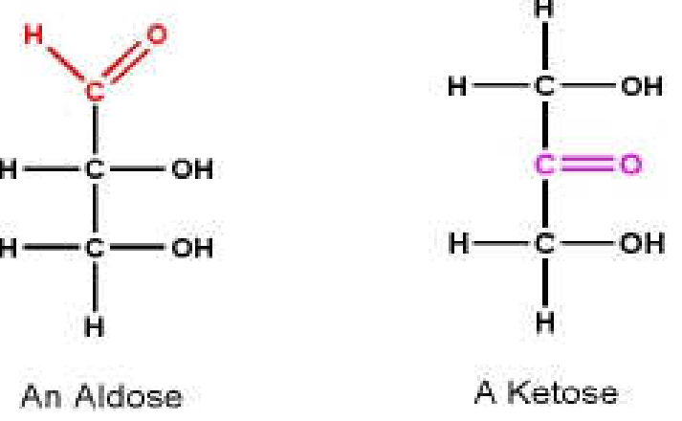
Fig. 10: Aldose vs Ketose.

Table: Classification of Sugars
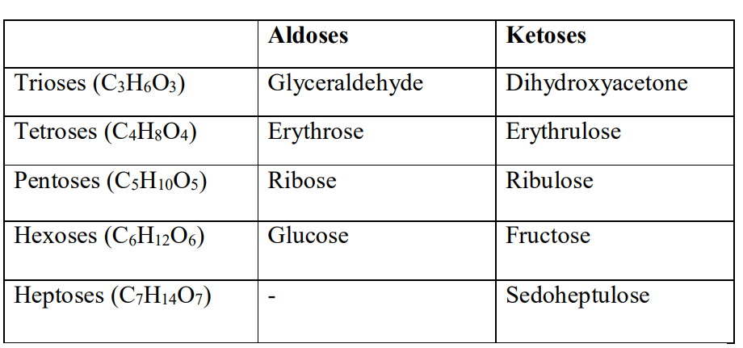
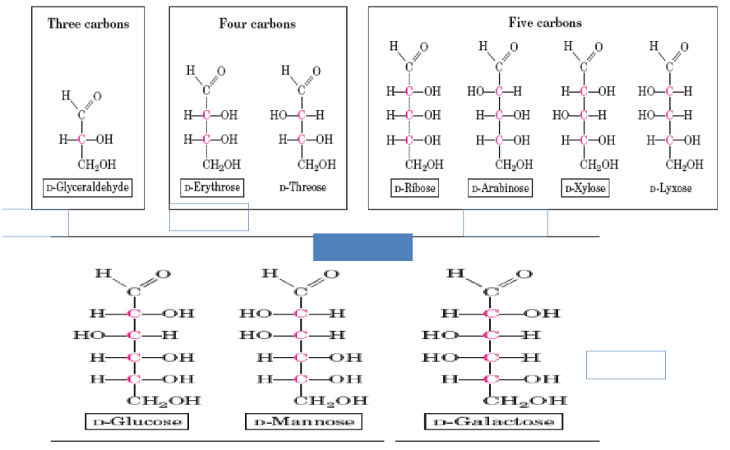
Fig. 11: Sugars with different no of Carbon Atoms.

Structure of Glucose
The straight chain structural formula of glucose can account for some of its properties, but a cyclic structure, formed by a reaction between the aldehyde group and an OH group is thermodynamically more favoured and accounts for other properties. The cyclic structure results from the reaction between the aldehyde group in C1 and the OH group in C5, forming a hemiacetal linkage and producing either of 2 stereoisomers.
The structure can also be represented in form of a chair, with the 6 membered ring containing one oxygen atom.
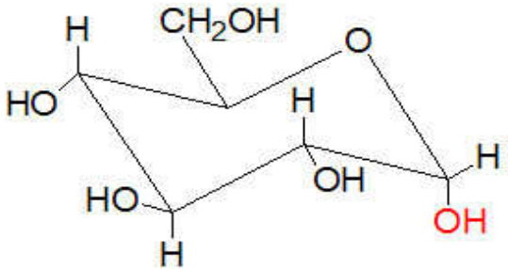
Straight chain Haworth projection Chair form
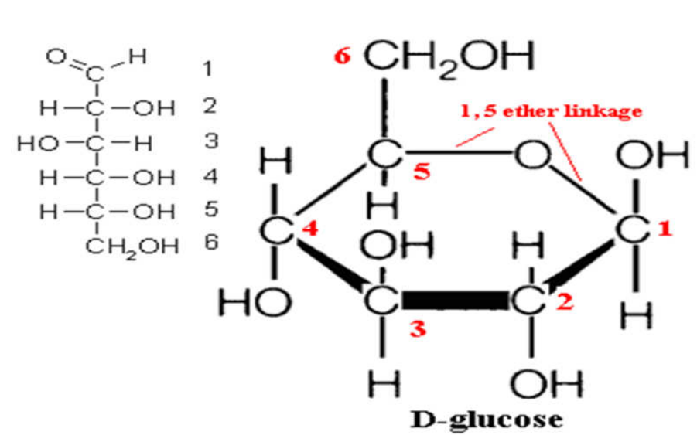
Fig. 12: Structures of Glucose.

Isomers of Glucose
Isomerism is the occurrence of compounds with the same chemical formula but different structural formula. The important types of isomerism found in glucose are D and L isomerism. The designation of a sugar isomer as the D form or of its mirror image as the L form is determined by its spatial relationship to the parent compound of the carbohydrates, glyceraldehydes. The orientation of the –H and –OH groups around the c atom adjacent to the terminal primary alcohol carbon determines whether the sugar belongs to the D or L series (when the –OH grp on this C is on the right, the sugar is the D isomer, when it is on the left, it is the L-isomer). Most of the naturally occurring monosaccharide are D sugars. The presence of asymmetric c atom also confers optical activity on the compound. When a beam of plane polarised light is passed through a solution of an optical isomer, it rotates either to the right (dextrorotatory, +) or to the left, (levorotatory -).
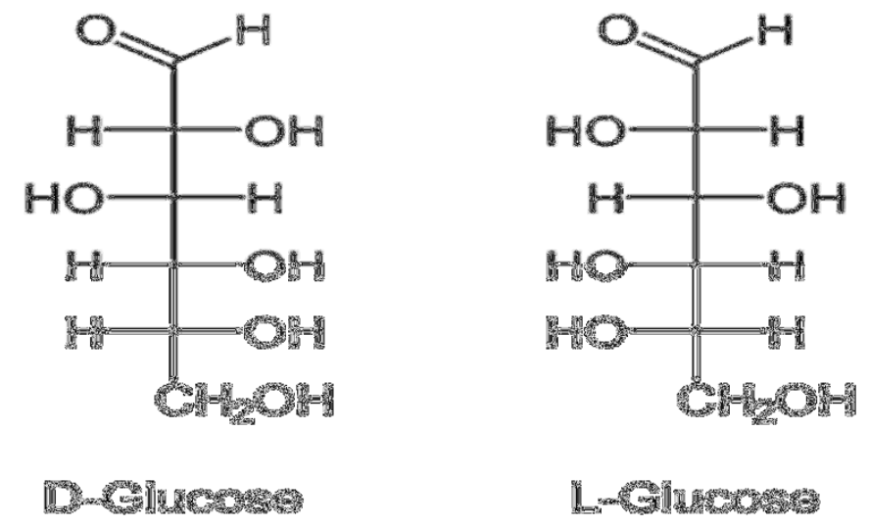
Fig.13: D and L forms of Glucose.

Pyranose and Furanose ring structures: Most monosaccharide spontaneously form ring structures in which the aldehyde or keto group forms a bond with one of its OH groups. If the ring contains 5 atoms, it is called a furanose ring; if it contains 6 atoms, it is called a pyranose ring. For glucose in solution > 99% is in the pyranose form.

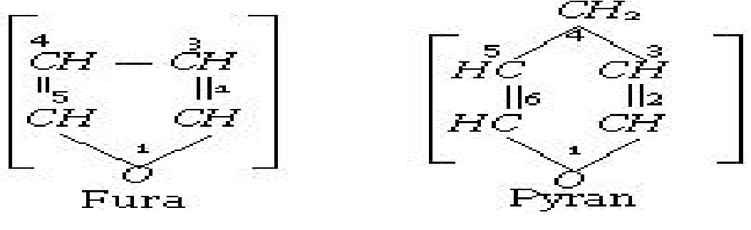
Fig.14: Furanose vs Pyranose Rings.

Alpha and Beta Anomers: Anomerism is the formation of rings that result in the creation of an assymetric carbon, called the anomeric carbon. If the –OH group on the anomeric carbon lies to the right of the carbon chain, it is considered to be in α- configuration, and in β- configuration if it lies to the left of the chain. (One of 2 stereoisomers of a cyclic saccharide that differs only in its configuration at the hemiacetal carbon, a hemiacetal is formed by combination of an aldehyde and an alcohol group).
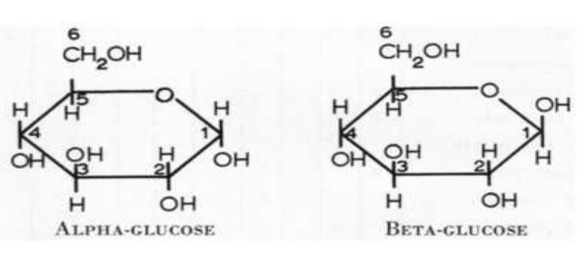
Fig. 15: Anomeric forms of Glucose.

Epimers: These are isomers differing as a result of variations in configurations of the –OH and –H on C atoms 2, 3 and 4 of glucose. The most important biological isomers of glucose are mannose (C2) and galactose C4).
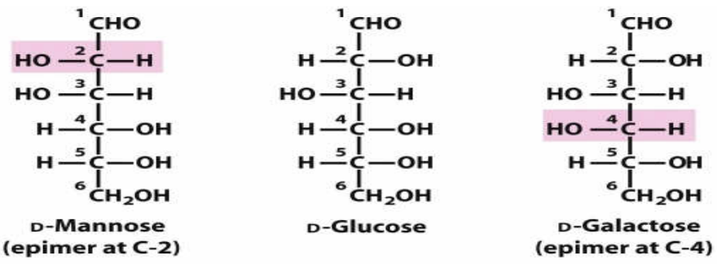
Fig. 16: Epimers of Glucose.

Aldose-Ketose Isomerism: Fructose has the same molecular formula as glucose but differs in its structure. Since it has a keto grp in position 2 whereas there is an aldehyde group in position 1 of glucose.
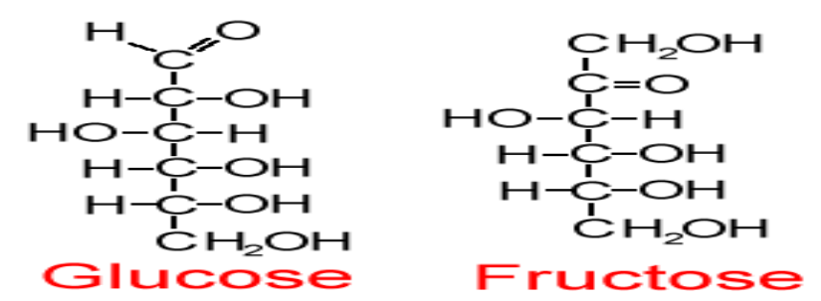
Fig 17: Aldose and Keto forms of Carbohydrates.

MUTAROTATION: D-glucose really exists in three different forms—an acyclic aldehyde and two cyclic hemiacetals- all of which are in equilibrium. Each cyclic hemiacetal can be isolated and crystallized separately, but when any one compound is placed in solution, an equilibrium mixture of all three forms results. This process is called mutarotation.
At equilibrium, the mixture has 36% of the α anomer, 64% of the β anomer, and only a trace amount of the acyclic aldehyde. The three forms of the D-glucose are shown below:

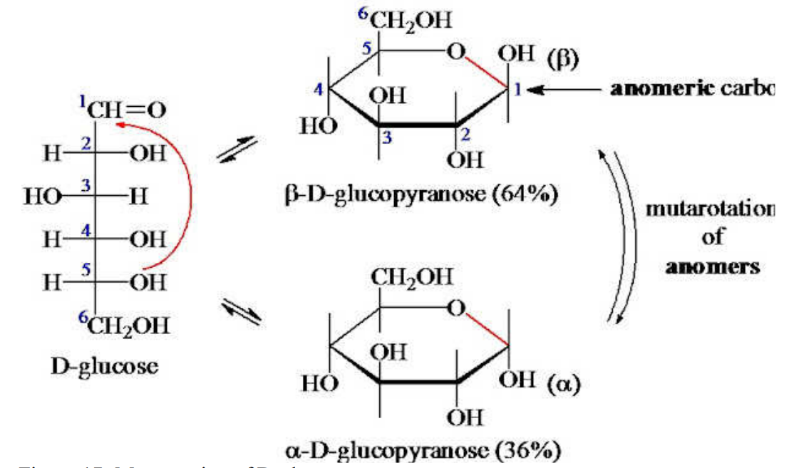
Figure 18: Mutarotation of D-glucose.

Reducing and Non-Reducing Sugars - When the anomeric carbon of a sugar is not attached to any other structure, the sugar can act as a reducing agent and is termed a reducing sugar. Such sugars can react with chromogenic agents (for example, Benedict's reagent or Fehling's solution) causing the reagent to be reduced and colored. The anomeric carbon of the sugar becomes oxidized to a carboxyl group. In some disaccharides e.g. sucrose both of the carbonyl groups are involved in glycosidic bond formation, so there are no free carbonyl groups. Such sugars are called non-reducing sugars. They do NOT reduce Benedict’s reagent.
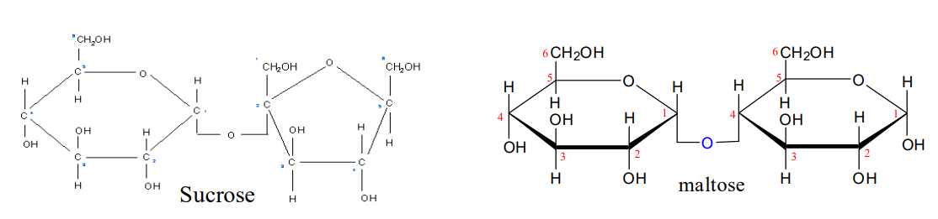
Figure 19: Reducing and non-reducing carbohydrates.

